【 神父感謝天父為他送來患有唐氏綜合症的嬰兒 】

秘魯一名神父Fr. Omar Sanchez Portillo在他51歲生日當天，接收了由社工送來的一名兩個月大患有唐氏綜合症的嬰兒住進他們的收容所「The Home of the Beatitudes真福八端之家」。 該名嬰兒的媽媽是一名嗜酒及患有精神分裂症的17歲少女，沒有能力照顧嬰兒。

神父為嬰兒改名為依市瑪耳Ismael，並感謝耶穌基督把這名孩子送給他作為生日禮物，使他的神職生命更摧完滿。他稱謝基督從未停止讓他驚喜!

神父十分尊敬聖德蘭修女，聖人的一句名言對他影響十分之大: 「不要墮胎，把孩子交給我!」神父籌辦「為生命步行」March For Life, 因為他們的收容所遵守「生命始於受孕一刻，直到自然的終結!」

他每天感謝天父把這工作委託給他，讓更多人接近天父，也使很多信徒回歸教會，十分有意義。當聽到有人指控教會不關注被遺棄的小童時，神父認為他們只是沒有注意教會的工作或只是惡意的批評，其實教會一直都明顯地在為此事工作。

「The Home of the Beatitudes真福八端之家」每年接收60名被遺棄的人，98%都患有殘疾、精神病、自閉症等。

#保護胎兒 #不墮胎 #領養 #寄養 #唐氏綜合症 #自閉症

Priest says baby with Down syndrome is a 'gift from God'
https://www.catholicnewsagency.com/news/priest-says-baby-with-down-syndrome-is-a-gift-from-god-20552
Lima, Peru, May 15, 2018 / 05:00 pm (ACI Prensa).- A priest who recently welcomed a newborn with Down syndrome into the children’s home he runs says that child is a gift from God.
The priest is Fr. Omar Sanchez Portillo, the director of the Home of the Association of the Beatitudes, located in the Lurín district of Lima, Peru. On his 51st birthday, Portillo was contacted by a social worker about a two-month-old baby with Down syndrome who was in need of a home. The child’s mother, only a teenager herself, was unable to care for him.
Portillo named the child Ismael.
“Thank you Jesus for the gift you have given me for my birthday! You never cease to surprise me, my Jesus. Welcome Ismael! Bringing you from Cusco has been a complete adventure, the first of many we're going to share together. Chromosome of love, Downs Syndrome,” the priest posted on his Facebook page.
In an interview with ACI Prensa, CNA's Spanish language sister agency, Portillo related that Ismael’s mother was an alcoholic, schizophrenic 17-year-old from a city in southern Peru.
“She went to the hospital to give birth. Apparently she had a difficult pregnancy, she gave birth and left him at the hospital. The Department for Women and Vulnerable Populations knows about our work, the profile of the kids we take in, and called us to receive him. I accepted that responsibility myself,” the priest said.
“He arrived on a very special day, May 5, my birthday, as a special gift from God in my priestly life, as its fruitfulness, as a spiritual father, as a human being. He is a very particular gift from God,” he added.
The Association of the Beatitudes, founded by Portillo, welcomes and provides comprehensive care—nutrition, healthcare, the sacramental life—for children, adolescents, and adults who suffer from physical or psychiatric disabilities, who have been abandoned on the streets or in garbage dumps or who live in extreme poverty.
The Home of the Beatitudes takes in about 60 people every year and currently houses 217 people. They also have a team of about 80 lay people that serve in this work of charity.
“Of the people that live there 98 percent have some disability, a different ability, or a psychiatric or physical illness. We have children who are visually impaired, have multiple disabilities (blind, deaf, mute), children with Down syndrome, intellectual disabilities, autism, adults and young people with mental illness, picked up off the streets,” the priest said.
Fr. Portillo told ACI Prensa that he is an admirer of Saint Teresa of Calcutta, from whom he borrowed the phrase: “Don't abort the child, give the child to me,” and says he does his own “March for Life” because the shelter he runs maintains “a commitment to life from conception to natural death.”
The priest said that those who criticize and accuse the Church of not caring about abandoned children “are either unaware or do it maliciously,” because “the work of the Church in all circumstances is evident.”
Noting that abortion is allowed in some countries when there is a fetal deformity or a genetic disorder is detected, Fr. Omar responded that “the world is losing an extraordinary treasure.”
“What these people really create is solidarity, leading others to open up their hearts and to be detached, it's a treasure the world cannot do without. They help us to come out of ourselves,” he added.
The priest said that he thanks God every day for the work with which he has been entrusted.
“For having given this priest who is a sinner such a huge, important and meaningful responsibility, and that through the work that God has entrusted to my heart and my hands, so many people have drawn close to God, so many people have converted and have returned to the Church. That is the significance,” he said.

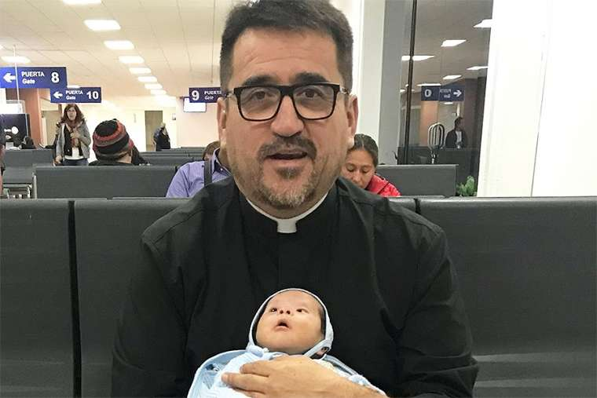
Fr. Omar Sanchez Portillo and Ismael

