一名越南建築師Tong，在2001年一次偶然機會在醫院見到一些懷孕婦女，本來大著肚子進入醫院，離開醫院時大肚子不見了，但手上卻沒有帶著嬰兒。Tong後來知悉這些婦女是進醫院進行墮胎手術。

Tong為這些被墮胎殺害的胎兒難過，他逐向有關當局申請取回這些被墮胎兒的遺體，在一個山坡上埋葬這些被殺害的胎兒。這15年來，他已經安葬了超過1萬名胎兒。

當Tong的善行被發現後，意想不到是有懷孕婦女找他收養她們打算墮掉的胎兒。起初Tong十分猶豫，因為他和妻子並不富有，但憑著一顆愛心領養了這些被遺棄的嬰兒後，他的故事吸引了一些熱心人士的捐助，至今他已收養了超過一百名孩子，他視為己出般愛著這群孩子!

#保護胎兒 #不墮胎 #領養
https://www.facebook.com/prolife.dpcmf/posts/1685820024825472

Selfless Vietnamese Man Offers to Bury Aborted Babies and Adopt Abandoned Children

http://www.viral4real.com/vietnamese-man-buries-aborted-babies/
He is now a father to more than 50 children and is still burying aborted children.
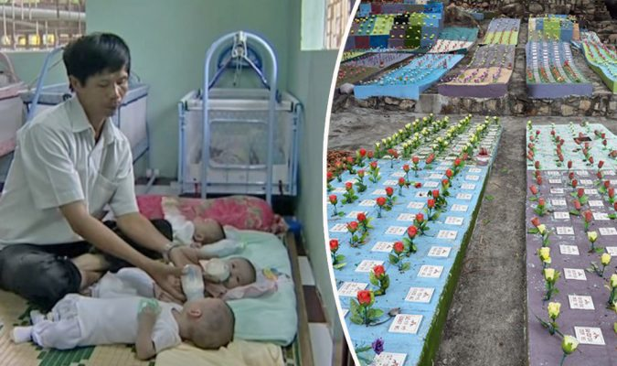
As young adults engage in premarital sex and married couples refuse to go through family planning, the number of unwanted babies are gradually increasing around the world. For some women, abortion is the only answer to their ‘problem’. Abortion is legal and is a government service available on request for women in some countries. In addition to virtually universal access to contraception, abortion is a way for these countries to contain its population.
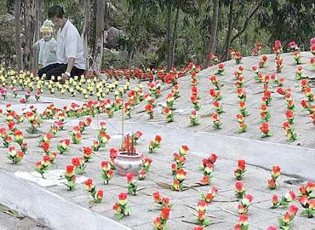
In the southeastern region of Vietnam, the rate is far higher, at 80 percent, compared to other Asian countries. Among Vietnamese women in the reproductive age, the rate of abortion is 83 per 1,000 women and the frequency of abortion is 2.5, which means every woman does 2.5 abortions in their reproduction life on average.
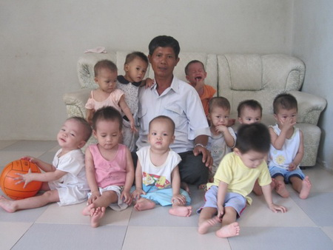
Vietnamese building contractor Tong Phuoc Phuc couldn’t contain his emotions upon seeing young mothers have their children aborted in a hospital where he accompanied his wife back in 2001. He saw pregnant walking in, and walking out with a smaller belly but without a baby. He soon realized those women came for abortions. He then decided to do a selfless act that eventually gave him recognition.
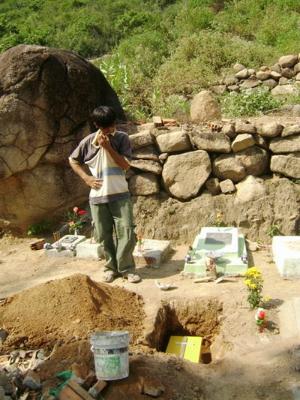
He asked Vietnamese authorities to allow him to give the babies proper burials. Once the Vietnamese government allowed him to do so, he picked up a spot on top of a mountain called Hon Thom in the city of Nha Trang, where he buried more than 10,000 babies in 15 years.
News spread throughout Vietnam regarding Tong’s selfless act, which prompted many women to ask him for ‘help’. Instead of having their children aborted, they asked Tong to take care of them instead. Tong was reluctant, knowing they were not rich, and having to take care of hundreds of children would be really hard.
Thankfully, after his story went viral, a lot of people reached out and helped Tong support the children. Today, he fathers more than a hundred children, whom he loves like his own!
https://youtu.be/QGzeBbYAzV4

