加洲強行各公立中學及大學為學生提供免費墮胎藥物，這是教育下一代的正確方法嗎?
美國加利福尼亞州參議院剛通過一個新的議案SB24: 強行所有的公立中學及大學，在校院內為學生提供免費的墮胎藥物。此種墮胎藥物可使懷孕10週以內的孕婦墮胎。
民主黨代表Connie Leyva解釋一直爭取通過此法案的理由是: 無須學生舟車勞頓往別處進行終止懷孕手術，也可以避免學生因此缺課。
維護生命組織Californians for Life發言人Marylee Shrider表示: 跟據美國食品及藥物管理局 (FDA) 記錄顯示，超過4,000宗因自行服食墮胎藥物而發生嚴重問題事件，當中超過1,000名女子需要入院留醫；另外，至小有22名女子因服用了墮胎藥物而死亡。
教區婚姻與家庭牧民委員會「關顧生命事工」為學校 / 堂區提供免費講座: 《墮胎可把問題解決?》 歡迎於辦公時間內致電2560-2314聯絡陳小姐查詢。
#保護胎兒 #不墮胎
https://www.facebook.com/prolife.dpcmf/posts/2543197652421034?__tn__=-R

California Senate Committee Passes Bill Mandating Free Abortions at All Colleges and Universities
APR 5, 2019
https://www.lifenews.com/2019/04/05/california-senate-committee-passes-bill-mandating-free-abortions-at-all-colleges-and-universities/?fbclid=IwAR2zlxrLf58lFKtUUxvwi4cbSoQterclzH076s0qaPXDRMj6cH_C3kn01go
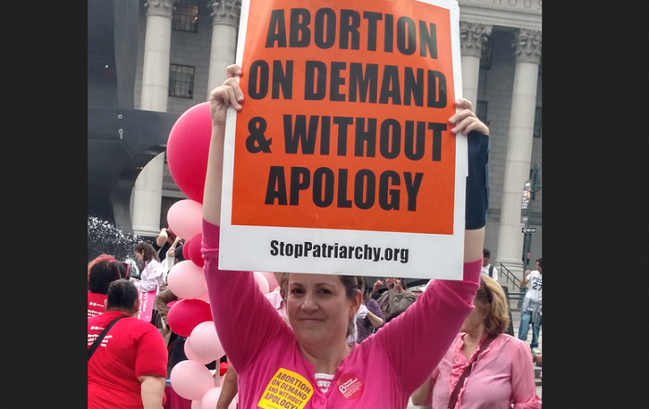
Share this story:
A California Senate committee approved an abortion expansion bill Wednesday that would force all public colleges and universities to provide abortion drugs to students on campus.
ADVERTISEMENT
The Daily Californian reports the state Senate Health Committee voted 7-3 to move forward with Senate Bill 24, a new version of a bill that even pro-abortion Gov. Jerry Brown called “unnecessary” in 2018.
The bill would require all public colleges and universities in California to provide abortion drugs to students on campus. It would require that the drugs be offered for free to students up to 10 weeks of pregnancy.
“SB 24 is an important step toward ensuring the right to abortion is available to all Californians and that our college students don’t face unnecessary barriers,” said state Sen. Connie Leyva, the sponsor, in a statement. “Students should not have to travel off campus or miss class or work responsibilities in order to receive care that can easily be provided at a student health center.”
Leyva, a pro-abortion Democrat, pushed similar legislationin 2018. However, Brown vetoed it, saying the measure was “not necessary” because abortions already are easily accessible to college students in California.
“According to a study sponsored by supporters of this legislation, the average distance to abortion providers in campus communities varies from five to seven miles, not an unreasonable distance,” Brown said when he vetoed the bill. “Because the services required by this bill are widely available off-campus, this bill is not necessary.”
Click Like if you are pro-life to like the LifeNews Facebook page and receive the latest pro-life news.
Leya re-introduced her bill anyway this year, and new Gov. Gavin Newsom has said he supports it.
On Wednesday, pro-life advocates urged the committee to consider the potential risks and liabilities of forcing colleges to provide abortion drugs.
Marylee Shrider, political advocacy chair for Californians for Life, cited FDA statistics showing the serious risks associated with abortion drugs. The FDA has documented at least 4,000 cases of serious adverse events, including more than 1,000 women who required hospitalization; in addition, at least 22 women died after using the drug.
“Medication abortions on college campuses are not only unnecessary, they are contraindicated,” Shrider said.
She pointed to Brown’s statement debunking the notion that students have to travel hours to get abortions.
However, student abortion activist Phoebe Abramowitz at UC Berkeley told the committee that students do not have “equitable access” to abortion on campus.
“Students are really, really supportive of SB 24,” Abramowitz said. “Students don’t need to accept a watered-down definition of pro-choice — we can and must demand actual equitable access for all of us.”
But the legislation does not support choices for pregnant and parenting students. It supports abortions. Nowhere in the legislation are provisions for students who chose to parent their child. There is no requirement that campuses offer prenatal care to pregnant students or child care to parenting students.
Initially, California public colleges and universities opposed Leyva’s bill because of safety concerns and liabilities. They pointed out that college health centers are not equipped to provide abortions. Additionally, most college health centers are not open in the evenings or on weekends, so they would not be able to treat complications.
California is one of the most radical states in regards to abortion access. Later term, elective abortions are legal, and girls as young as age 12 can obtain abortions without parental knowledge or consent.
Action: Contact California state lawmakers in opposition to the bill.

