一名年輕女士Katy意外懷孕，醫生診斷她的孖生胎兒將會胎死腹中，並建議她墮胎。Katy斷言拒絕，因她堅信一對孩子有出生權。結果一男一女的孖生兒比預期早了出生，照顧他們是疲憊的事。

但Katy從不後悔當日的決定，盡力照顧孖生兒女，現在經已5個月大，最近獲醫生通知他們發展不錯，可快將出院回家了。

#保護胎兒 #不墮胎
https://www.facebook.com/prolife.dpcmf/posts/1491123830961760

Doctors Told Mom to Abort Her Twin Babies Because They Would Die at Birth. Now They’re 5 Months Old
INTERNATIONAL
MICAIAH BILGER JUN 6, 2017 | 1:54PM LONDON, ENGLAND
http://www.lifenews.com/2017/06/06/doctors-told-mom-to-abort-her-twin-babies-because-they-would-die-at-birth-now-theyre-5-months-old/
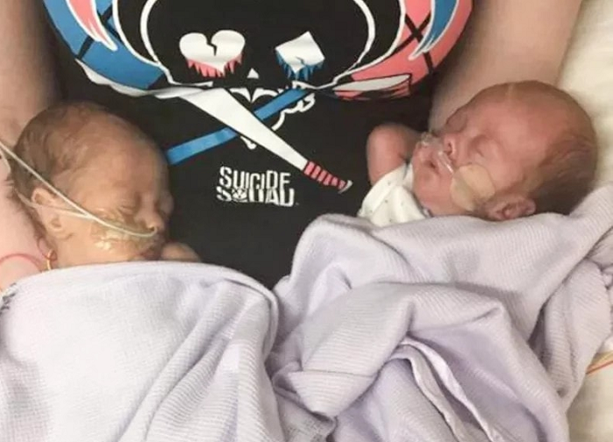
Share this story:
A single mom facing an unplanned pregnancy, Katy Lambert listened as doctors suggested that she have an abortion. Doctors said her twins probably would be stillborn, and Lambert was in a difficult spot in life.
ADVERTISEMENT
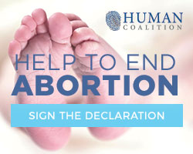
ADVERTISEMENT
For some, abortion may have appeared to be the best thing for the struggling 20-year-old. But Lambert said no because she believed her unborn babies deserved a chance at life.
The British mother gave birth to the twins Jackson, a boy, and Harley, a girl, on Jan. 3 in Northampton, England, Tuko reports. The twins were alive but they were very premature, arriving after just 24 weeks and 6 days in the womb, according to the report.
Lambert, a twin herself, said her pregnancy and the twins’ arrival were very stressful. She said she did not have a lot of family support, and the twins’ health constantly was fluctuating. One day, Harley would be doing well and Jackson would be struggling for his life, and the next day their situations would reverse, she said.
She told The Sun:
Katy split up with the twins’ dad, and said she doesn’t have much family support so felt alone.
“But I remember during Harley’s first surgery just having this realisation of ‘I can do this’,” she added.
SUPPORT PRO-LIFE NEWS! Please help LifeNews.com with a donation
“They weren’t planned but they are the best thing that’s happened to me.
“It has been so hard but they have done incredibly and watching them fight and be so strong has made me stronger. I am completely in love with them.”
The twins have spent more than five months in the hospital, and Lambert said doctors expect they will be well enough to go home soon.
“It has not been easy an easy road but I am so proud of how far the twins have come…” she said. “It has been a living hell watching them hooked up to ventilators and feeding tubes and going through all their surgeries and blood transfusions.”
Lambert said she is so grateful for the support she and the twins received from doctors and nurses at the hospital.
“We’ve still got a little way to go before they can come home but there is actually light at the end of the tunnel,” she said. “I never thought I would even get to think about that day. They really are my little miracles.”
Premature babies like Lambert’s twins have a better chance of surviving than they ever did before, thanks to modern medical technology. Though 24 weeks is considered the standard point of viability, new studies indicate babies born before 24 weeks are surviving at higher rates than ever before. Many argue that the point of viability should now be about 22-23 weeks.
In the UK, abortions are legal up to 24 weeks for any reason, though some families of babies born before 24 weeks are urging lawmakers to change the law.

