【母親拒絕把患臉癌的胎兒墮丟 女孩現已16歲】

Evelyn在懷孕時診斷胎兒患上臉部淋巴癌，醫生指胎兒不能活多過一歲，並建議墮胎，Evelyn拒絕醫生建議，堅持把女兒Jacqueline誕下。Jacqueline現已16歲，明年中學畢業，志願是當一名護士，照顧患病的人。

Jacqueline雙頰、舌頭、胸口均佈滿不正常的組織，她以電腦與人溝通、以飼管進食，但Jacqueline從不氣餒，她學習結他、也是一名網球好手。父母Evelyn及Paul對女兒的努力十分自豪，也十分欣賞女兒的毅力，表示女兒是對他們最好的禮物。

Jacqueline分享自己的故事，希望人們不要以患病去判斷一個人，別人的歧視確實令她傷心，但她表示: 「我是一名正常的人類，我擁有一般人也有的健康組織。」

#保護胎兒 #不墮胎 #關顧病患 #關顧傷殘

https://www.facebook.com/prolife.dpcmf/posts/1742678152472992

Girl with giant facial tumours defies odds by turning 16: ‘I’m just a normal human being’
HER parents claim that she is the best thing that ever happened to them.
https://www.dailystar.co.uk/real-life/671385/teenager-rare-condition-facial-tumours-survives
By Sophie Roberts / Published 4th January 2018
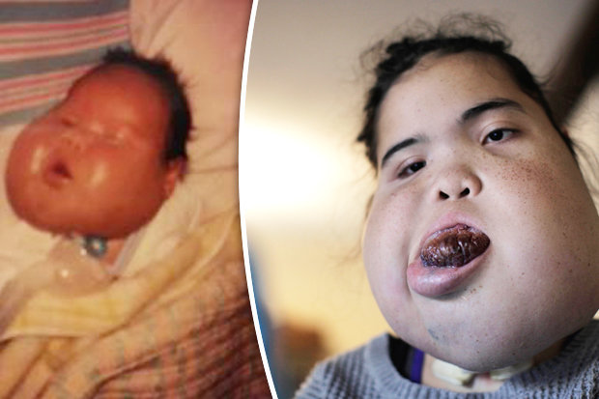BARCROFT TV
AGAINST ALL ODDS: Jacqueline has defied predictions made by doctors
A student with a rare facial tumour has exceeded doctor's expectations by making it to her 16th birthday.
Experts believed that Jacqueline Rodriguez, who is set to graduate from college next year, would not live for more than a year.
The teenager’s symptoms have left her unable to speak or eat, but she’s determined to fulfil her dreams of becoming a nurse.

Rare Medical Conditions

Featuring the rarest diseases and disorders from around the globe.
1 / 32
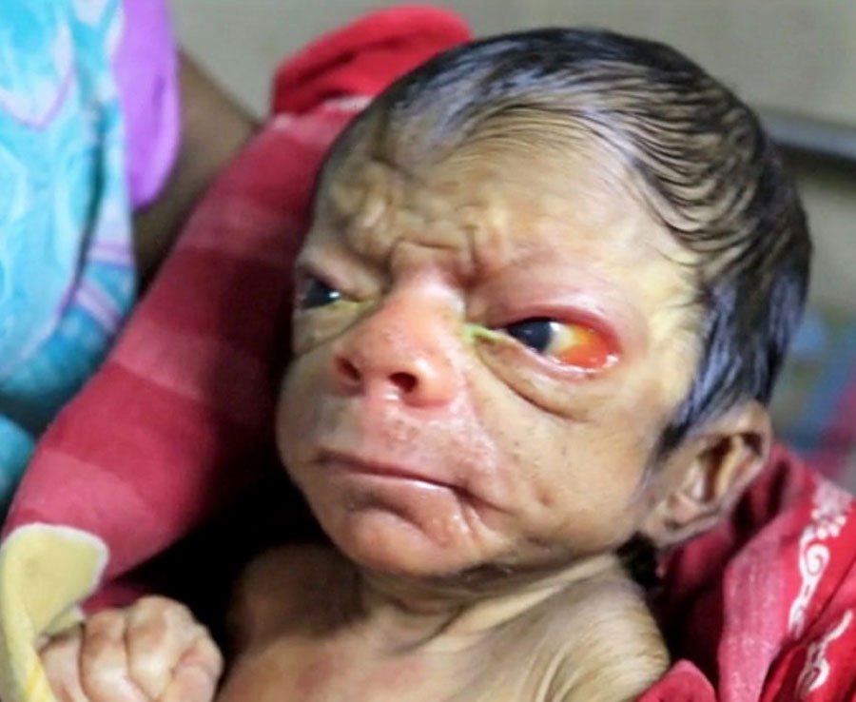CATERS NEWS AGENCY
The baby boy has wrinkles on the face, has a very shrunken body and hollow eyes. The baby does not look like a new born at all.
- 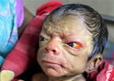
- 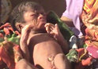
- 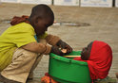
- 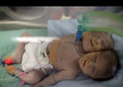
- 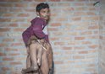
- 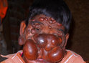
When Jacqueline’s mum Evelyn was pregnant, doctors spoke to her about the possibility of a termination.
Fearing that the baby would have a poor quality of life, some believed that abortion could be the better option.
Mum Evelyn, 52, said: “When I was still pregnant with Jacqueline, doctors were telling us our daughter might not get to see her first birthday.”
Despite this, the teenager has proven professionals wrong by living her life to the full.
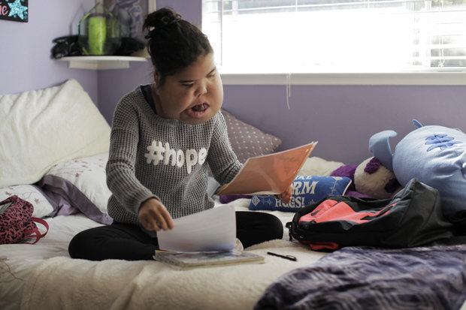BARCROFT TV
GIVING BACK: Jacqueline hopes she can help others by working as a doctor
Jacqueline was born with lymphatic malformations, an extremely rare condition that leads to tumours.
These masses of tissue have formed on her cheeks, tongue and chest, restricting her ability to carry out tasks that most people take for granted.
She has to speak through an iPad and eat through a formula tube, but refuses to let this hold her back.
Not only does she take regular guitar lessons, she’s also a keen tennis player who dreams of studying nursing at Stanford University.

The promising student revealed: “I want to be a nurse because I grew up in a hospital helping my nurses take care of others.”
Jacqueline’s parents couldn't be prouder of their daughter.
Her mum said: "She is achieving so much and her self-esteem has truly blossomed – it’s incredible.
“And I just didn’t think we’d be here at this point. I’m so grateful."

Dad Paul added: “She has got so much perseverance.
“That little girl just wants to live. Every day she wakes up with a smile on her face and it just encourages you.
“She has been the best thing that happened to us.”

Jacqueline hopes that sharing her story will remind others that her illness does not define her.
She said: “People normally stare at me and point a lot.
“People do say mean things. It makes me feel sad because they don’t know me enough to say mean things.
“I’m a normal human being. I have health issues like everyone else.”

