My wife became pregnant after rape. Surprisingly, the baby helped us both heal
Nov 6, 2017
https://www.lifesitenews.com/opinion/my-wife-was-brutally-raped-and-had-a-baby.-surprisingly-the-child-helped-us

「我的妻子被姦成孕，這孩子卻治癒了我們的傷口」

Jeff的太太Jennifer不幸被強暴，兩夫婦陷入非常痛苦的深淵。 Jeff不停怪責自己沒有好好保護妻子，他非常憤怒，甚至在沐浴時用拳頭猛擊牆壁。

更令他們震驚的是，Jennifer因姦成孕。縱管各方面都認為繼續懷孕只會令Jennifer勾起痛苦的回憶，但Jeff說: 妻子被強暴的痛苦回憶不需要被勾起，已經永遠烙印在她的記憶中，揮之不去。Jennifer反而說胎兒給予她希望活下去。 Jeff在知悉妻子因姦成孕的一剎那，傷口開始被治癒。

他們認為這名孩子是天主的補贖，使他們的噩夢得以治癒。Jeff引用依撒意亞書第61章3節 - 「給熙雍悲哀的人一項冠冕來代替灰塵，喜樂的油以代替喪服，頌讚以代替沮喪的心神。他們將被稱為正義的橡樹，上主為光榮自己所種植的園地。」

Jeff 及Jennifer原本已經育有4名子女，他們清楚知道這名即將來臨的孩子是無辜的，他們明白是天主委託他們照顧這名孩子。他們逐期待孩子的來臨，Jeff視這名小兒子為己出，其他四名子女也清楚知道小弟弟來到他們家庭的原因，但他們愛著這最小的弟弟如同其他兄弟姊妹，沒有任何間隙。他們讓孩子們清楚知道生命是始於受孕的一刻，不能放棄。

Jeff說他們不會判斷其他被姦成孕而墮胎的婦女，他們明白在開首的時段，她們對腹中的孩子會懷有很可怕的敵意，但Jeff他們克服了。透過信仰，他們明白要好好保護這個小生命，以光榮天主。Jennifer經常說: 「發生了的，不能回頭，故要向前走!」

Jeff表示: 孩子出生後如何安排，由你決定，但你總會發現身邊很多人樂意提供協助!

祈禱是他們的力量，他們也經常為其他有相同遭遇的婦女祈禱!

#保護胎兒 #不墮胎
https://www.facebook.com/prolife.dpcmf/posts/1668068906600584

Note: Jennifer Christie's own account of her ordeal can be read here: After a brutal rape, I became pregnant. Doctors told me to abort. My husband and I did this instead.
November 6, 2017 (Save the 1) -- I understand what women mean when they say that men don’t have as much of a right to talk about abortion after rape as it doesn’t have anything to do with them. That statement has some truth to it. Sometimes. But when it happened to my bride of 22 years, when she was raped, I was deeply affected. Our amazing 3-year-old was conceived on that horrific day. He is a gift that helped us both recover.
I’ve read the comments. I’ve heard the opinions. I agree that you don’t know what you’ll think or feel in such a situation unless it happens to you. That’s a terrible, stark reality and one I live with. I know that I can’t take away the trauma that my wife went through no matter how much I try. I recognize that I can’t and won't ever comprehend the depth of her pain.
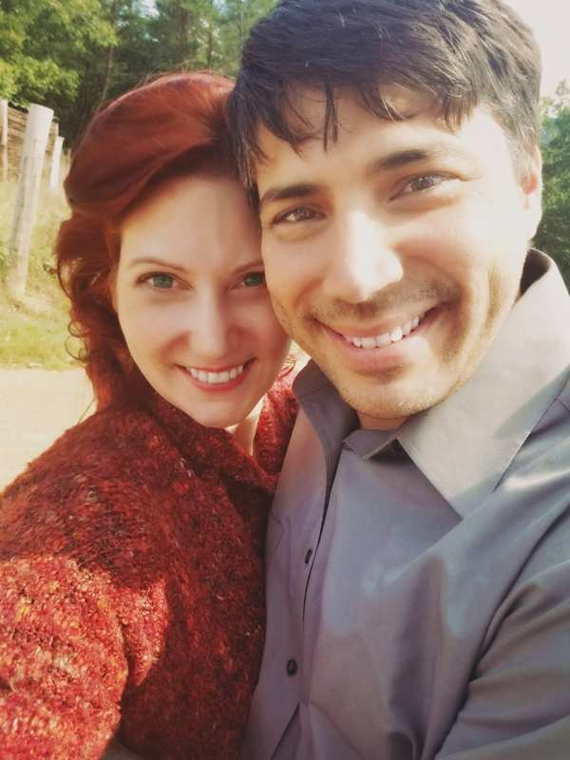Jeff and Jennifer Christie.
She also won't understand mine. I’m supposed to be her protector. I’m the one who stood in front of our families and friends and, along with "for better, for worse...", silently vowed to make sure her heart and body stay safe. So where was I when she needed me the most? I live with constant “what-ifs” and “Why didn’t I” thoughts.
I saw, before anyone else could, that the woman I knew from the time she was a bubbly, outgoing 14 year old whose quick wit made everybody laugh, that she was never going to be the same. I also recognized that our son had nothing to do with the horror she went through. I knew she would never forget what was done to her, regardless of whether he existed or not. It’s ignorant arrogance that brings about comments like “With a child, a victim of rape has to live with that reminder every day of what that monster did to her.” She doesn’t need a reminder. That kind of violation is forever imprinted in her memory.
What are children conceived in rape if not these terrible “reminders”? I can tell you from personal experience.
They are chances at redemption. They are opportunities for healing and a way to find meaning from nightmarish, meaningless actions. Isaiah 61:3 says that He provides those who mourn with “…beauty for ashes, the oil of joy for mourning, the garment of praise for the spirit of heaviness.”
My wife likes to say that our son gave her hope. A purpose. I SAW that spark light up in her heart, and I knew then that without having a purpose come from all the violence, without another soul to protect and nurture, she would forever feel alone in her victimhood. She might always wonder why this happened to her, a loving child of God. This evil rapist left behind two victims: The woman he violated, and the life that began with his heinous actions.
Full disclosure: I, too, began to heal with the news of our son’s conception. (I did say our son. My beloved and I are one. If she is pregnant, then WE are having a baby.) I spent the first few weeks after the rape, while being the bastion of strength and solidity that my bride needed, slamming my fists into the wall in the shower. In two decades of marriage, I hadn't ever questioned my effectiveness as her knight and protector. I was in anguish, not able to see past the pain that I couldn't help but feel responsible for...turmoil over what I couldn't protect her from. I am in no way trying to compare my experience with her torment, her loss of self, but I would be remiss to not speak up on behalf of men who have been tangentially impacted by sexual assault through a woman they love. We are wounded. The collateral damage is great.
But the child...
He heals. He teaches. He encourages us. He forces us to focus on something outside of ourselves. He is an opportunity for us as parents to bring another loving, compassionate soul into the world. He is a blank slate, and the wonderful and humbling burden for his impact on the world is on us. He’s not our only child. He’s the youngest of five. Just like the others, he was placed in our lives by a God who entrusted all of them to our care. As with all our children, our love for him started the moment we knew he existed. We welcomed him into our fold with the same devotion and reverence as his brothers and sister. They all love each other-usually-as siblings, and none of them consider him different or lesser, they are all equal partners in their mission to survive our parenting . They know how he came about but it's evident that they just don’t think about it when they look at him. This child-like acceptance that their brother is just here in the world and he is innocent of how, encourages us as parents. Our kids have reinforced the mindset that a child’s life and impact start at conception-not a second sooner.
To the women who have aborted after rape, I tell you unequivocally that we cast no judgment. We understand more than most that the decision you are faced with in the early months after such a trauma, when you are still trying to make sense of the world, is overwhelming. The pressure to feel animosity towards the child you’re carrying is horrendous. We lived through that. We know how the future can feel so unstable that you want more than anything to reduce the turmoil in your head in any way that you can. In our case there really was no decision. Without discussion we knew we'd honor God and our beliefs and protect this little soul from harm. You may not have had such support. All we offer is the knowledge that God forgives and allows us to learn. It’s the beauty of human experience that we can continue to make changes throughout our lives. He can make us new. All we have to do is ask.
To those who have been assaulted and find yourself in the position of carrying new life, we offer comfort & support. Prayers and love. Reach out to us. We know that you will not forget, but over time you will heal. My wife likes to say ,“There is no going back, but there is moving forward.” There is acceptance of a new reality and learning how to live every day. I stress the fact that the person growing inside of you is unique. You are not alone. Yes, your life is different now, but that normalcy was stripped away by your assailant, not the child now growing inside of you. That child is also a victim of evil intentions. In almost 4 years, my wife’s body has not completely healed from the attack. You,too, may have long-lasting physical and emotional scars. A woman’s body should never suffer that kind of violation. But when you get down to the basics, that body WAS miraculously designed to protect and grow life.
What happens after birth is completely up to you; there are always options. ALWAYS people to help.
I finish with a tribute to my amazing wife and the incredible women she has found along her journey since we began sharing this part of our life. True heroines. Hearing their inspiring stories of grit and courage always leave me speechless. I have to shake my head when I hear people say that not all women are strong enough to carry a child in this circumstance or after that trauma. I don’t agree. I’ve seen my wife give birth five times. I’ve watched her hold her head high in situations that would make iron men crumble. The strength of women should never be underestimated.
I didn't become pregnant after rape.. but my wife did. My life also changed forever that day. So don't tell me my opinion doesn't matter. It does. Don't tell me I can't argue for life in the womb. I will. And please don't tell me I have no idea what a woman goes through.

