「沒有腦袋的男孩」

在Shelly懷孕三個月時，醫生在產檢時發現胎兒有幾種嚴重的健康問題，包括: 脊柱裂、染色體異常、腦積水等等。同時發現胎兒的腦部只得2%的組織，相信胎兒在出生前或出生期間會死亡。醫生曾前後五次建議Shelly及丈夫Rob進行墮胎，夫婦倆皆拒絕，堅持要給兒子一個生存的機會。

男嬰Noah平安誕生了，發現由胸口以下皆是癱瘓的。但Shelly夫婦豪不介意，只要兒子能活下來，其他都不重要。

Noah現在已經4歲了，需要使用輪椅或支架走路，他跟其他小孩一樣能唱歌、說話、愛笑，最重要是他的腦部組織正在發展至正常大小，而且接近正常運作。

縱使Noah的未來發展仍有很多未知之數，但Shelly夫婦每天都在為兒子感恩。為了協助其他育有脊柱裂孩子的家庭，Shelly夫婦捐贈了兩部輪椅給當地一間兒童醫院。

如果當初Shelly夫婦沒有堅持給兒子Noah一個生存機會，Noah今天不會有如此理想的發展。

男孩Noah證明了墮胎不會是選擇。

#保護胎兒 #墮胎

https://www.facebook.com/prolife.dpcmf/posts/1191110037629809

‘The Boy Without a Brain’ stuns doctors after parents refuse abortion
October 18, 2016 Live Action News
http://liveactionnews.org/boy-without-brain-stuns-doctors-after-parents-refuse-abortion/
At three months gestation Shelly Wall and her husband Rob learned the devastating news no parent wants to hear. Doctors told them their preborn baby boy Noah had several health problems including spina bifida, chromosome abnormalities, and hydrocephalus. They said Noah only had 2% of his brain tissue and would likely die at or before birth. The couple was advised to abort their son.
They refused.
Four years later, Noah is doing remarkably well and has been featured in a new U.K. documentary.
“We were offered termination five times,” Rob Wall said in the documentary, “The Boy Without a Brain.” “It was never an option for us. To me, we wanted to give Noah that chance of life.”
Doctors had made such a strong case that Noah would die at birth that the couple planned a funeral for their son before he was even born. But to their great joy, after Noah was born on March 6, 2012, he let out a cry.
Noah was paralysed from the chest down, but to his parents that didn’t matter. All that mattered was that he was alive.
“The first thing we heard when he was born was him taking a breath and then crying, which was unbelievable,” recalled Shelly Wall.
Surgery was performed on Noah’s back which had a large hole in it. He also had a drain placed in his head to clear the cerbrospinal fluid that was pressing on his brain. Noah was sent home, but would return to the hospital on numerous occassions due to medical complications. Still, the little boy continued to not only survive, but also to prove doctors wrong.
Noah uses both a wheelchair and braces to get around…but get around he does. Plus, not only does he sing, talk, and smile, but his brain has been expanding.
“[…] to hear his brain’s almost back to normal is beyond belief,” Shelly Wall said. “Rob and I broke down when we heard the news. It was like a dream. I’ve never known anything like it. Even the consultants were in tears. Every time we see the doctors, they just shake their head. They’re just amazed at what he can do.”
The future is still uncertain for Noah. His family knows he will face more surgeries and challenges, but they are grateful for every day they have with him. To help other families experience similar joy, they raise awareness for spina bifida and have donated two wheelchairs to Great North Children’s Hospital in Newcastle. In addition, Noah’s brain scans are being used to study spina bifida, which could lead to breakthroughs in treatments for other children.
Doctors say Noah’s brain is now nearly fully-functional — a miracle after such a heartbreaking prognosis. Noah’s life is precious, and if his parents hadn’t held onto hope and believed their son deserved a chance, he wouldn’t be here today to do the good he’s doing.
Noah proves abortion is never the answer.
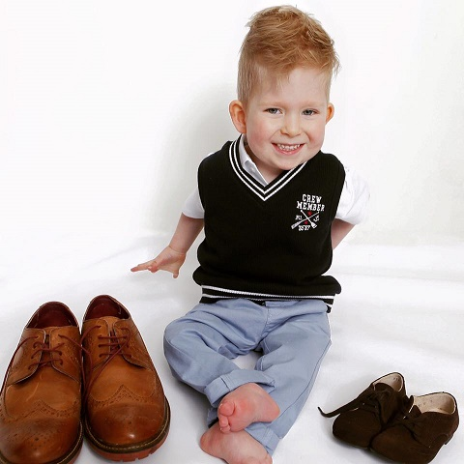
Photo via Facebook.

